25th Anniversary of the Devastating 1998 Ice Storm in the Northeast

January 5, 2023 – This week marks the 25th Anniversary of the 1998 Ice Storm that devastated parts of northern New England, northern New York and especially the St. Lawrence River valley of Canada from January 5th through January 9th, 1998.

This storm had historic impacts across northern New York, northern New England, and southeast Canada due to the prolonged duration of the event, magnitude of the ice accretion and precipitation amounts. Although the actual weather event lasted from January 5th-9th, the impacts and recovery efforts of power restoration, clearing debris and “returning to normal” lasted weeks, even months for those hardest impacted.

The most infamous aspect of this storm was the destructive ice accumulation of up to four inches (100 mm) in portions of northern New York and southeast Canada, with heavy ice accumulation of 3/4-2 inches across portions of northern New England. In addition, the amount of liquid equivalent precipitation that fell across the region during these five days, including more than five inches of rain in the Black River Valley in upstate New York, led to major flooding.

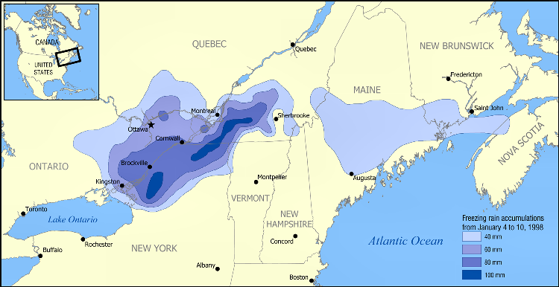

Some of the devastating impacts included the power grid with hundreds of large transmission towers toppled, thousands of poles snapped, and utility lines downed resulting in millions of without power, some for longer than 2 weeks. The agriculture industry suffered great losses immediate and long term. Local farmers suffered many losses from structural damage due to ice loading, tons of lost milk production and losses of cattle due to the inability to milk. Additionally, thousands of maple and apple trees were damaged or destroyed that had significant impacts for years due to lost crops. Moreover, millions of acres of forests were damaged or destroyed by this event.

Storm damage estimates for this storm were more than $4 billion ($1.4B in the U.S.) with approximately forty fatalities. This was and is still today the only billion-dollar natural disaster to impact northern New York, Vermont, New Hampshire, and Maine since 1980.

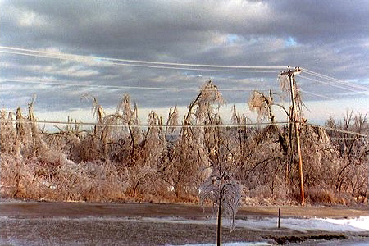

This historic winter storm had its origins from a strong El-Nino pattern that was influencing weather patterns during the winter of 1997-98. Moderate to strong El-Nino patterns are famous for their impacts across the West coast of the United States, especially California.

However, moderate to strong El-Nino's tend to influence the jet stream in two significant ways that can have affects well downstream including the Ice Storm of 1998. First, the subtropical Pacific jet is more active and brings more moisture to the Pacific coast and the southern tier of the United States. Second, the polar and arctic jet streams tend to stay across Canada with temperatures near or above normal across the continental United States.